Skytap Automation Pack for IBM UrbanCode Deploy

Introduction 3

Installation of the Skytap Automation Pack for IBM UrbanCode Deploy 4

Skytap Action Steps for IBM UrbanCode Deploy 6

Skytap Authentication 6

Input Properties 8

Output Properties 8

Add Environment to Project 9

Input Properties 9

Output Properties 10

Add Template to Environment 10

Parameters 11

Output Properties 12

Add Template to Project 12

Input Properties 13

Output Properties 14

Add VM from Template to Environment 14

Parameters 15

Output Properties 17

Bind Dynamic Agent to Component 17

Parameters 18

Output Parameters 18

Change Environment State 19

Input Properties 19

Output Properties 21

Change VM State 22

Input Properties 22

Output Properties 24

Connect to Network in another Environment (ICNR) 24

Input Properties 25

Output Properties 27

Connect to VPN Tunnel 27

Input Properties 28

Output Properties 29

Create Environment from Template 30

Parameters 30

Output Properties 31

Create Published Service for VM 31

Parameters 33

Output Properties 34

Create Published URL for Environment 34

Parameters 35

Output Properties 37

Create Template from Environment 37

Parameters 38

Output Properties 39

Delete Environment 40

Parameters 40

Output Properties 41

Delete VM from Environment 42

Parameters 42

Output Properties 43

Get VM ID 44

Parameters 44

Output Properties 45

List Published Service for VM 45

Parameters 47

Output Properties 49

List Published URL for Environment 49

Parameters 50

Output Properties 51

Set VM User Data 51

Parameters 52

Output Properties 53

# Introduction

[Skytap](http://www.skytap.com) is a self-service cloud that makes it easy for you to create development and test environments on demand within minutes. An environment can be as simple as a client application running on a single VM or as complex as a multi-component distributed application running on multiple VMs across multiple networks. Skytap makes it easy for you to set up these environments and save them off as “golden” templates. These templates in turn can be used to create clones of the environment, as many as needed, to run your test suites for unit testing, functional testing, integration testing, stress/performance testing or user acceptance testing.

The Skytap Automation Pack for IBM UrbanCode Deploy provides a set of pre-packaged Skytap actions for use in configuring an IBM UrbanCode Deploy workflow. These pre-packaged Skytap actions provide you with actions that are commonly needed in provisioning environment resources for use in an IBM UrbanCode Deploy workflow.

Specifically, the Skytap Step Actions provided in the Skytap Automation Pack are as follows:

* Skytap Authentication
* Add Environment to Project
* Add Template to Environment
* Add Template to Project
* Add VM from Template to Environment
* Bind Dynamic Agent to Component
* Change Environment State
* Change VM State
* Connect to Network in another Environment (ICNR)
* Connect to VPN Tunnel
* Create Environment from Template
* Create Published Service for VM
* Create Published URL for Environment
* Create Template from Environment
* Delete Environment
* Delete VM from Enviornment
* Get VM ID
* List Published URL for Environment
* List Published Service for VM
* Set VM User Data

Each of these Skytap Step Actions is described in detail in this document.

# Installation of the Skytap Automation Pack for IBM UrbanCode Deploy

You can install the Skytap Automation Pack for IBM UrbanCode Deploy directly from the IBM UrbanCode Deploy Web UI by navigating to the Settings->Automation Plugins page.

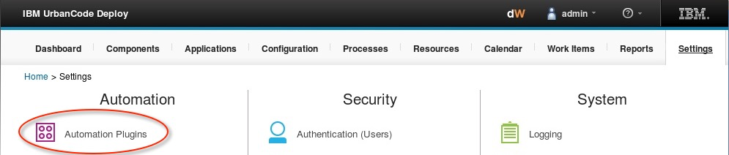

 Once there, click, the “Load Plugin” button

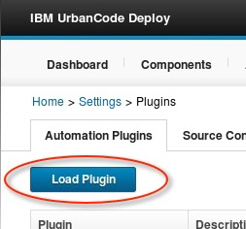

Browse for the Skytap Plugin for IBM UrbanCode Deploy zip file and then click the “Submit” button

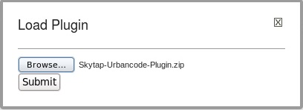

Once successfully loaded into IBM UrbanCode Deploy the Skytap Automation Pack for IBM UrbanCode Deploy will be visible in the list of Automation Plugins:

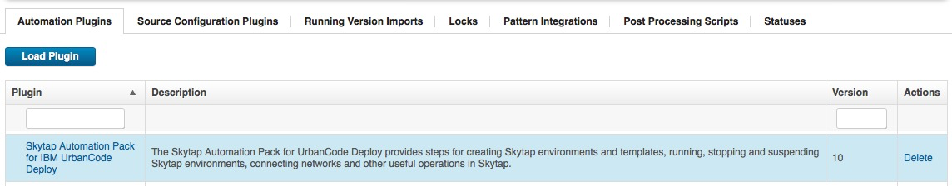

The Skytap Action Steps implemented by the Skytap Automation Pack for IBM UrbanCode Deploy will be available in the “Step Palette” panel in IBM UrbanCode Deploy process design pages:

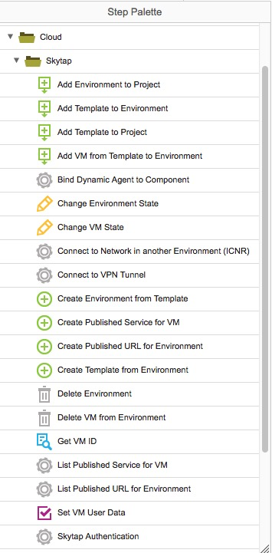

Depending on which action you select you will be presented with a set of input properties to specify in order to enable execution of the Skytap Action Step.  The specific input properties that are required differ depending on which Skytap Action step you select.  These properties are described below in the discussion of individual Skytap Actions.

# Skytap Action Steps for IBM UrbanCode Deploy

## Skytap Authentication

To use the Skytap Automation Pack for IBM UrbanCode Deploy you must first be able to authenticate with Skytap.  This authentication requires a Skytap user ID and an API Token.  This is needed so that the plugin can make API calls on your behalf to manage resources in your account on Skytap. Assuming you already have a Skytap account, you can retrieve your API Token in your Skytap Account Settings:

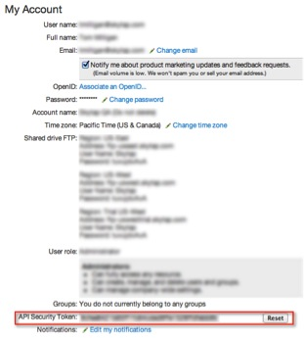

Once you have your security token, you will need to enter it along with your Skytap User ID in the Skytap Authentication action in your IBM UrbanCode Deploy workflow. Using the Skytap Authentication action step allows you to specify authentication credentials that can be inherited by subsequent Skytap action steps in your workflow.

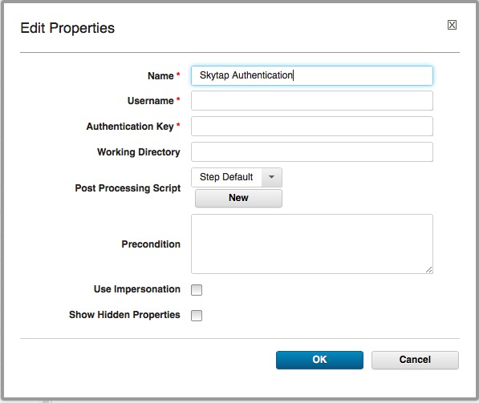

### Input Properties

#### Username

Your Skytap user ID

#### Authentication Key

Your Skytap API Security Token

### Output Properties

#### Username

Your Skytap user ID is available as an output property to this Skytap action step that can be used in subsequent Skytap action steps

#### Authentication Key

Your Skytap API Security Token is available as an output property to this Skytap action step that can be used in subsequent Skytap action steps

## Add Environment to Project

This Skytap action step allows you to specify a Skytap Environment to add to a Skytap Project.

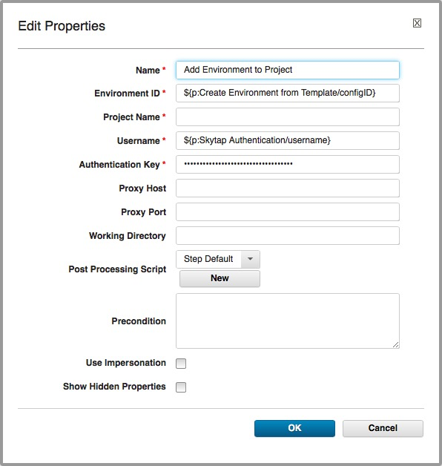

### Input Properties

#### Environment ID

The ID of the Skytap Environment to be added to the specified Skytap Project.

You can specify a specific Skytap Environment ID (an integer), if one is known.  If the environment was created using a “Create Environment from Template” Skytap step action, you can specify the Skytap environment by specifying the “configID” output property from the appropriate “Create Environment from Template” Skytap action step.

The default value for this property is the “configID” output property from the Skytap action step titled “Create Environment from Template”

#### Project Name

The Skytap Project Name to which the specified environment is to be added.

If there is more than one Skytap Project with the specified name (not recommended), the last Skytap Project with the specified name that is encountered in the meta data project list will be used.

#### Username

Your Skytap User ID

The default value for this property is the “username” property from the Skytap action step titled “Skytap Authentication”.

#### Authentication Key

Your Skytap API Security Token

The default value for this property is the “password” property from the Skytap action step titled “Skytap Authentication”.

#### Proxy Host

The optional name of the proxy to use to connect to Skytap Cloud

#### Proxy Port

The optional proxy port on the above proxy host to use to connect to Skytap Cloud

### Output Properties

None

## Add Template to Environment

The Virtual Machines contained in the Skytap Template identified by the specified Skytap Template ID are added to the Skytap Environment identified by the specified Skytap Environment ID.

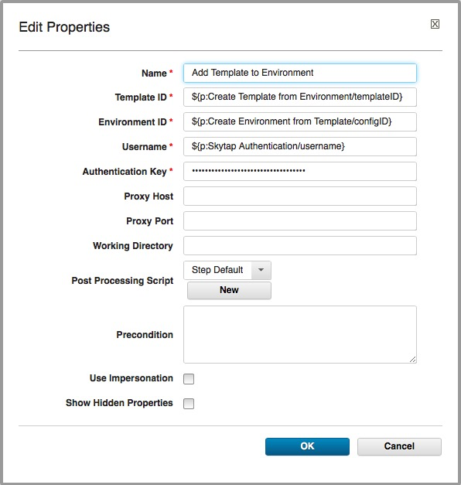

### Parameters

#### Template ID

The ID of the Skytap Template that contains the VM definitions to be added to the specified Skytap Environment.

You can specify a specific Skytap Template ID (an integer), if one is known.  If the template was created using a “Create Template from Environment” Skytap step action, you can specify the Skytap template by specifying the “templateID” output property from the appropriate “Create Template from Environment” Skytap action step.

The default value for this property is the “templateID” output property from the Skytap action step titled “Create Template from Environment”

#### Environment ID

The ID of the Skytap Environment to which the VMs in the specified Skytap Template are to be added.

You can specify a specific Skytap Environment ID (an integer), if one is known.  If the environment was created using a “Create Environment from Template” Skytap step action, you can specify the Skytap environment by specifying the “configID” output property from the appropriate “Create Environment from Template” Skytap action step.

The default value for this property is the “configID” output property from the Skytap action step titled “Create Environment from Template”

#### Username

Your Skytap User ID

The default value for this property is the “username” property from the Skytap action step titled “Skytap Authentication”.

#### Authentication Key

Your Skytap API Security Token

The default value for this property is the “password” property from the Skytap action step titled “Skytap Authentication”.

#### Proxy Host

The optional name of the proxy to use to connect to Skytap Cloud

#### Proxy Port

The optional proxy port on the above proxy host to use to connect to Skytap Cloud

### Output Properties

None

## Add Template to Project

This Skytap action step allows you to specify a Skytap Template to add to a Skytap Project.

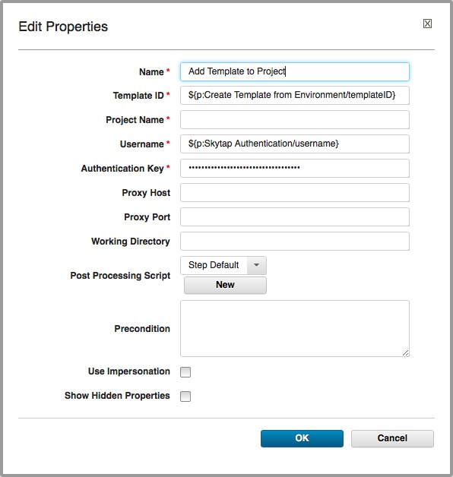

### Input Properties

#### Template ID

The ID of the Skytap Template that is to be added to the specified Skytap Project.

You can specify a specific Skytap Template ID (an integer), if one is known.  If the template was created using a “Create Template from Environment” Skytap step action, you can specify the Skytap template by specifying the “templateID” output property from the appropriate “Create Template from Environment” Skytap action step.

The default value for this property is the “templateID” output property from the Skytap action step titled “Create Template from Environment”

#### Project Name

The Skytap Project Name to which the specified template is to be added.

If there is more than one Skytap Project with the specified name (not recommended), the last Skytap Project with the specified name that is encountered in the meta data project list will be used.

#### Username

Your Skytap User ID

The default value for this property is the “username” property from the Skytap action step titled “Skytap Authentication”.

#### Authentication Key

Your Skytap API Security Token

The default value for this property is the “password” property from the Skytap action step titled “Skytap Authentication”.

#### Proxy Host

The optional name of the proxy to use to connect to Skytap Cloud

#### Proxy Port

The optional proxy port on the above proxy host to use to connect to Skytap Cloud

### Output Properties

None

## Add VM from Template to Environment

The specified Virtual Machine contained in the Skytap Template identified by the specified Skytap Template ID is added to the Skytap Environment identified by the specified Skytap Environment ID.

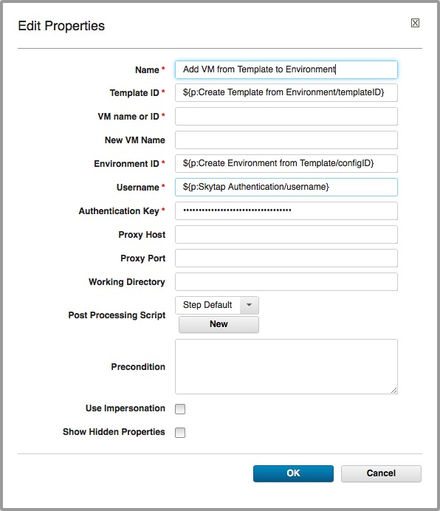

### Parameters

#### Template ID

The ID of the Skytap Template that contains the VM definitions to be added to the specified Skytap Environment.

You can specify a specific Skytap Template ID (an integer), if one is known.  If the template was created using a “Create Template from Environment” Skytap step action, you can specify the Skytap template by specifying the “templateID” output property from the appropriate “Create Template from Environment” Skytap action step.

The default value for this property is the “templateID” output property from the Skytap action step titled “Create Template from Environment”

#### VM name or ID

The name or numerical ID (an integer) of the virtual machine contained in the specified Skytap template.

#### New VM Name

A name to assign to the new VM after it has been added to the specified Skytap template. If no name is provided, the name of the new VM will be the same as it’s name in the originating template.

#### Environment ID

The ID of the Skytap Environment to which the specified VM in the specified Skytap Template are to be added.

You can specify a specific Skytap Environment ID (an integer), if one is known.  If the environment was created using a “Create Environment from Template” Skytap step action, you can specify the Skytap environment by specifying the “configID” output property from the appropriate “Create Environment from Template” Skytap action step.

The default value for this property is the “configID” output property from the Skytap action step titled “Create Environment from Template”

#### Username

Your Skytap User ID

The default value for this property is the “username” property from the Skytap action step titled “Skytap Authentication”.

#### Authentication Key

Your Skytap API Security Token

The default value for this property is the “password” property from the Skytap action step titled “Skytap Authentication”.

#### Proxy Host

The optional name of the proxy to use to connect to Skytap Cloud

#### Proxy Port

The optional proxy port on the above proxy host to use to connect to Skytap Cloud

### Output Properties

#### vmID

The numeric ID (an integer) of the VM added to the specified Skytap environment.

## Bind Dynamic Agent to Component

This step interacts with IBM UrbanCode Deploy to do the following:

1. Associate an IBM UrbanCode Deploy agent with an already-created Top-Level Group resource.
2. Add an IBM UrbanCode Deploy component to the agent that was added to the Top-Level Group 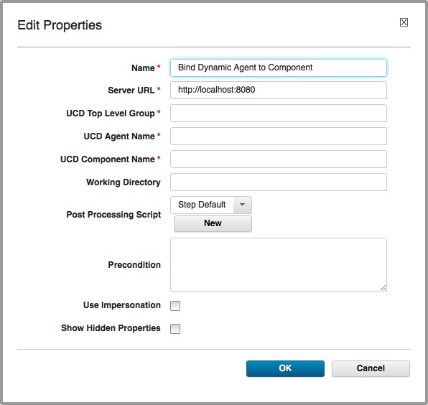

### Parameters

#### Server URL

The URL to the IBM UrbanCode Deploy server.

#### UCD Top Level Group

The name of the IBM UrbanCode Deploy Top-Level Group resource to which to associate the specified agent.

#### UCD Agent Name

The name of the IBM UrbanCode Deploy agent to associate with the specified Top-Level Group resource

#### UCD Component Name

The name of the IBM UrbanCode Deploy component to add to the specified Agent.

### Output Parameters

None

## Change Environment State

This Skytap action step allows you to specify a state to which the specified environment is to be transitioned.

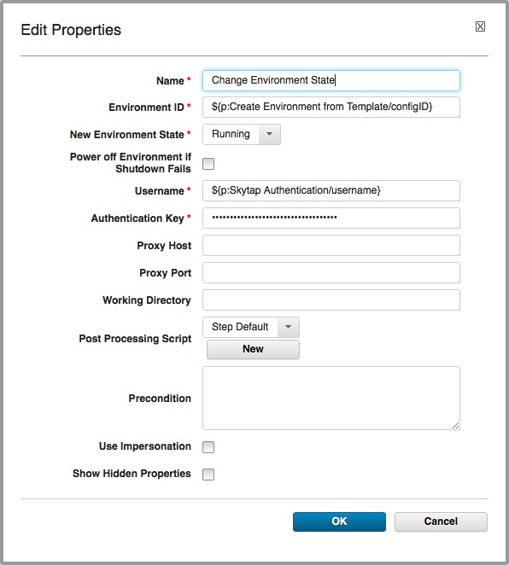

### Input Properties

#### Environment ID

The Environment ID of the Skytap Environment for which a state change is to be executed.

You can specify a specific Skytap Environment ID (an integer), if one is known.  If the environment was created using a “Create Environment from Template” Skytap step action, you can specify the Skytap environment by specifying the “configID” output property from the appropriate “Create Environment from Template” Skytap action step.

The default value for this property is the “configID” output property from the Skytap action step titled “Create Environment from Template”

#### New Environment State

The state to which the specified Skytap Environment is to be transitioned. Choices are “Running”, “Suspended”, and Shutdown”.

#### Power off Environment if Shutdown Fails

The “Power off Environment if Shutdown Fails” checkbox serves as a failsafe if a environment fails to shutdown. If this checkbox is checked, and the specified Skytap Environment fails to shutdown after a period of 5 minutes, the specified Skytap Environment will be forcefully shutdown or “powered off”. This is equivalent to clicking the “Power off this machine” button in the Skytap Web GUI.

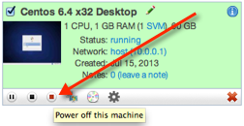

#### Username

Your Skytap User ID

The default value for this property is the “username” property from the Skytap action step titled “Skytap Authentication”.

#### Authentication Key

Your Skytap API Security Token

The default value for this property is the “password” property from the Skytap action step titled “Skytap Authentication”.

#### Proxy Host

The optional name of the proxy to use to connect to Skytap Cloud

#### Proxy Port

The optional proxy port on the above proxy host to use to connect to Skytap Cloud

### Output Properties

None

## Change VM State

This Skytap action step allows you to specify a state to which the specified environment is to be transitioned.

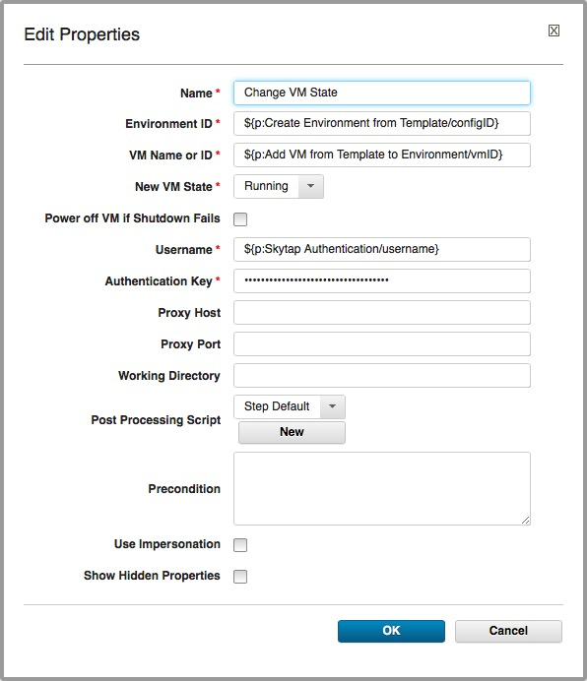

### Input Properties

#### Environment ID

The Environment ID of the Skytap Environment that contains the virtual machine for which a state change is to be executed.

You can specify a specific Skytap Environment ID (an integer), if one is known.  If the environment was created using a “Create Environment from Template” Skytap step action, you can specify the Skytap environment by specifying the “configID” output property from the appropriate “Create Environment from Template” Skytap action step.

The default value for this property is the “configID” output property from the Skytap action step titled “Create Environment from Template”

#### VM Name or ID

The name or numerical ID (an integer) of the virtual machine contained in the specified Skytap template

#### New VM State

The state to which the specified Skytap virtual machine is to be transitioned. Choices are “Running”, “Suspended”, and Shutdown”.

#### Power off VM if Shutdown Fails

The “Power off Environment if Shutdown Fails” checkbox serves as a failsafe if a environment fails to shutdown. If this checkbox is checked, and the specified Skytap virtual machine fails to shutdown after a period of 5 minutes, the specified Skytap virtual machine will be forcefully shutdown or “powered off”. This is equivalent to clicking the “Power off this machine” button in the Skytap Web GUI.



#### Username

Your Skytap User ID

The default value for this property is the “username” property from the Skytap action step titled “Skytap Authentication”.

#### Authentication Key

Your Skytap API Security Token

The default value for this property is the “password” property from the Skytap action step titled “Skytap Authentication”.

#### Proxy Host

The optional name of the proxy to use to connect to Skytap Cloud

#### Proxy Port

The optional proxy port on the above proxy host to use to connect to Skytap Cloud

### Output Properties

None

## Connect to Network in another Environment (ICNR)

When this Skytap action step is selected, the specified networks in the two specified environments will be connected using the Internal Environment Network Routing (ICNR) protocol.  This feature is useful during testing, where one or more test environments need to access a central resource, like a database or Active Directory server. The network subnets in the two environments must already be configured to allow an ICNR connection to occur. You can read more about ICNR in the [Skytap Help Documentation](https://cloud.skytap.com/docs/index.php/Networking_Between_Configurations).

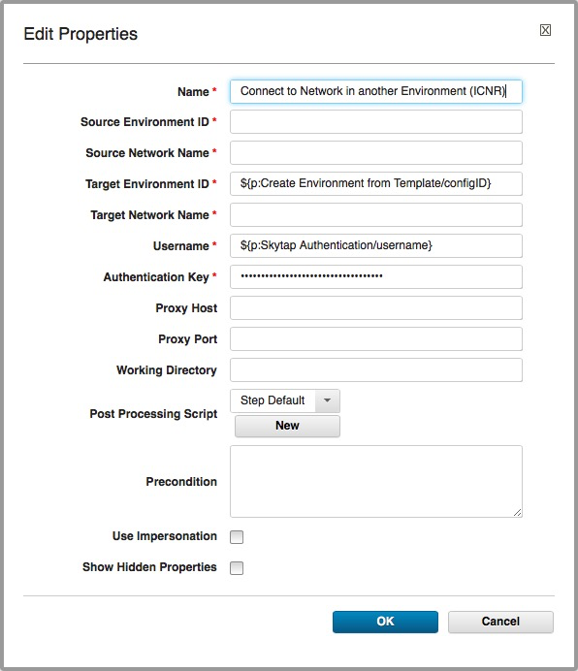

### Input Properties

#### Source Environment ID

The ID of the Source Environment to use in the ICNR connection attempt.

You can specify a specific Skytap Environment ID (an integer), if one is known.  If the environment was created using a “Create Environment from Template” Skytap step action, you can specify the Skytap environment by specifying the “configID” output property from the appropriate “Create Environment from Template” Skytap action step.

#### Source Network Name

The name of the network in the Source Environment to use in the ICNR connection attempt.

If there is more than one network in the environment with the specified name (not recommended), the last network encountered with the specified name in the meta data associated with the environment will be used.

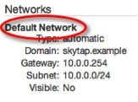

#### Target Environment ID

The ID of the Target Environment to use in the ICNR connection attempt.

You can specify a specific Skytap Environment ID (an integer), if one is known.  If the environment was created using a “Create Environment from Template” Skytap step action, you can specify the Skytap environment by specifying the “configID” output property from the appropriate “Create Environment from Template” Skytap action step.

The default value for this property is the “configID” output property from the Skytap action step titled “Create Environment from Template”

#### Target Network Name

The name of the network in the Source Environment to use in the ICNR connection attempt.

If there is more than one network in the environment with the specified name (not recommended), the last network encountered with the specified name in the meta data associated with the environment will be used.

The network in the Target Network Name must be configured to be visible to other networks.

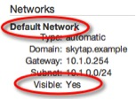

#### Username

Your Skytap User ID

The default value for this property is the “username” property from the Skytap action step titled “Skytap Authentication”.

#### Authentication Key

Your Skytap API Security Token

The default value for this property is the “password” property from the Skytap action step titled “Skytap Authentication”.

#### Proxy Host

The optional name of the proxy to use to connect to Skytap Cloud

#### Proxy Port

The optional proxy port on the above proxy host to use to connect to Skytap Cloud

### Output Properties

None

## Connect to VPN Tunnel

When this Skytap step action is selected, the specified Skytap VPN definition will be connected to the specified network in the specified Skytap Environment.

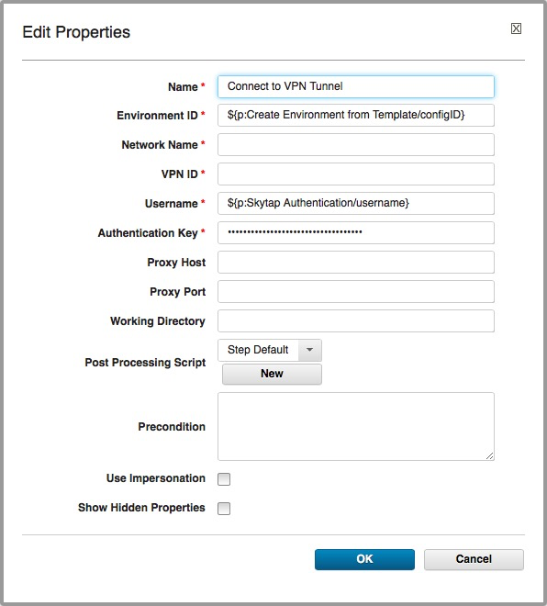

### Input Properties

#### Environment ID

The ID of the Source Environment to use in the VPN connection attempt.

You can specify a specific Skytap Environment ID (an integer), if one is known.  If the environment was created using a “Create Environment from Template” Skytap step action, you can specify the Skytap environment by specifying the “configID” output property from the appropriate “Create Environment from Template” Skytap action step.

The default value for this property is the “configID” output property from the Skytap action step titled “Create Environment from Template”

#### Network Name

The name of the network in the specified environment to use in the VPN connection attempt.

If there is more than one network in the environment with the specified name (not recommended), the last network encountered with the specified name in the meta data associated with the environment will be used.



#### VPN ID

This parameter is the Integer ID of the Skytap VPN definition to which to connect the specified network in the environment.

#### Username

Your Skytap User ID

The default value for this property is the “username” property from the Skytap action step titled “Skytap Authentication”.

#### Authentication Key

Your Skytap API Security Token

The default value for this property is the “password” property from the Skytap action step titled “Skytap Authentication”.

#### Proxy Host

The optional name of the proxy to use to connect to Skytap Cloud

#### Proxy Port

The optional proxy port on the above proxy host to use to connect to Skytap Cloud

### Output Properties

None

## Create Environment from Template

This Skytap step action allows you to specify a Skytap Template from which to create a Skytap Environment.   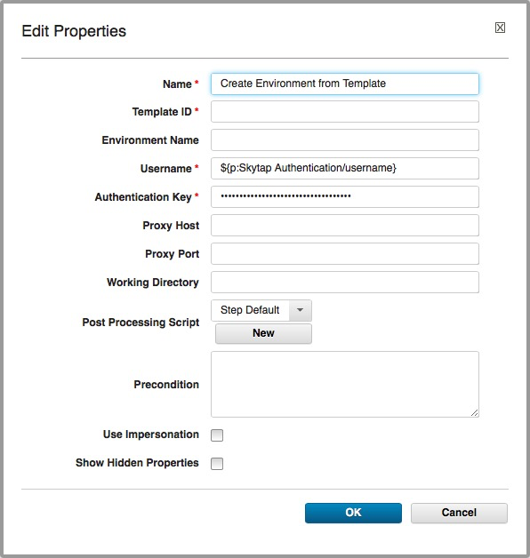

### Parameters

#### Template ID

The ID of the Skytap Template to use in creating a new Skytap Environment.

You can specify a specific Skytap Template ID (an integer), if one is known.  If the template was created using a “Create Template from Environment” Skytap step action, you can specify the Skytap template by specifying the “templateID” output property from the appropriate “Create Template from Environment” Skytap action step.

#### Environment Name

This parameter allows you to specify a name for the created environment.

#### Username

Your Skytap User ID

The default value for this property is the “username” property from the Skytap action step titled “Skytap Authentication”.

#### Authentication Key

Your Skytap API Security Token

The default value for this property is the “password” property from the Skytap action step titled “Skytap Authentication”.

#### Proxy Host

The optional name of the proxy to use to connect to Skytap Cloud

#### Proxy Port

The optional proxy port on the above proxy host to use to connect to Skytap Cloud

### Output Properties

configID

This property can then be used as input to subsequent Skytap step actions that require a Skytap Environment ID using the IBM UrbanCode Deploy ${p:Create Environment from Template/configID} property syntax.

## Create Published Service for VM

When this Skytap step action is selected, a [Skytap Published Service](https://cloud.skytap.com/docs/index.php/Exposing_a_Configuration_to_the_Public_Internet#Setting_Up_a_Published_Service) will be added to the port number specified by the “Port Number” parameter in the network with the name specified by the “Network Name” parameter in the virtual machine specified by “VM Name” parameter in the environment specified by the “Environment ID” property.

If the specified environment has more than one Virtual Machine with the name specified by the “Virtual Machine Name” parameter, the last Virtual Machine with the specified name that is listed in the environment metadata will be used.

If the specified environment has more than one network with the name specified by the “Network Name” parameter, the last network with the specified name that is listed in the environment metadata will be used.

The text of the published service and port in the form “public-URL:port-number” is saved in the “serviceAddress” output property.

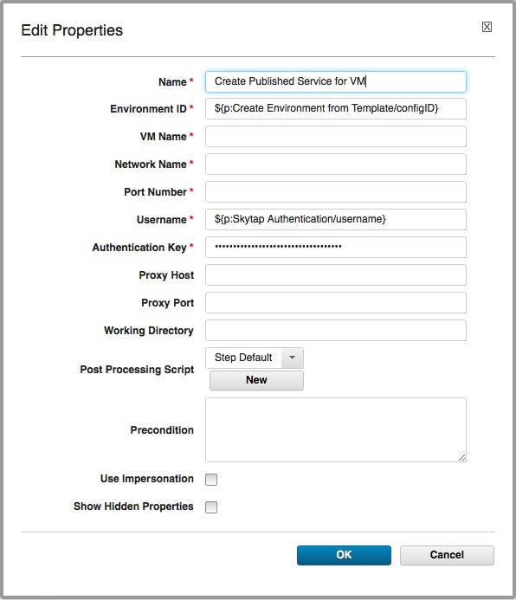

### Parameters

#### Environment ID

The ID of the environment containing the VM for which a Skytap Published Service is to be created.

You can specify a specific Skytap Environment ID (an integer), if one is known.  If the environment was created using a “Create Environment from Template” Skytap step action, you can specify the Skytap environment by specifying the “configID” output property from the appropriate “Create Environment from Template” Skytap action step.

The default value for this property is the “configID” output property from the Skytap action step titled “Create Environment from Template”

#### VM Name

This parameter specifies the name of the Virtual Machine to which the Published Service is to be attached.

Note that if the specified environment has more than one VM with the same name, the last VM with that name that is encountered in the Skytap Environment metadata definition will be selected.

#### Network Name

This parameter specifies the Network to which the Published Service is to be attached.

Note that if the specified VM has more than one network with the same name, the last network with that name that is encountered in the Skytap Environment metadata definition will be selected.

#### Port Number

This parameter specifies the Port to which the Published Service will be connected.

#### Username

Your Skytap User ID

The default value for this property is the “username” property from the Skytap action step titled “Skytap Authentication”.

#### Authentication Key

Your Skytap API Security Token

The default value for this property is the “password” property from the Skytap action step titled “Skytap Authentication”.

#### Proxy Host

The optional name of the proxy to use to connect to Skytap Cloud

#### Proxy Port

The optional proxy port on the above proxy host to use to connect to Skytap Cloud

### Output Properties

serviceAddress

The text of the public URL and port in the form “public-URL:port-number” is saved in the “serviceAddress” output property.

This property can then be used as input to subsequent IBM UrbanCode Deploy workflow steps.

## Create Published URL for Environment

When this Skytap Action is selected, a [Skytap Published URL](https://cloud.skytap.com/docs/index.php/Getting_Started_with_Skytap_Cloud#Sharing_Your_Configuration_Using_Published_URLs) will be created and associated with the specified Environment.

The text of the published service is saved in the “publishedURL” output property. 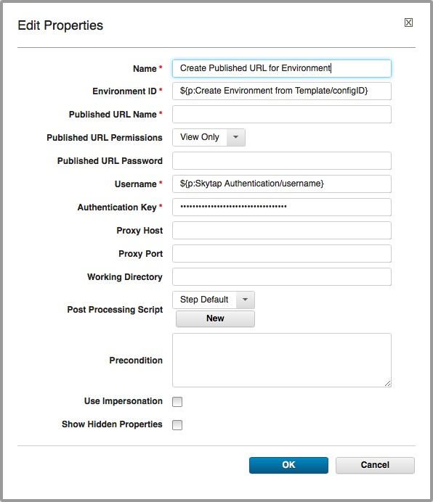

### Parameters

#### Environment ID

The Environment ID of the Skytap Environment for which the Published URL is to be created.

You can specify a specific Skytap Environment ID (an integer), if one is known.  If the environment was created using a “Create Environment from Template” Skytap step action, you can specify the Skytap environment by specifying the “configID” output property from the appropriate “Create Environment from Template” Skytap action step.

The default value for this property is the “configID” output property from the Skytap action step titled “Create Environment from Template”

#### Published URL Name

The name to be associated with the Published URL.

#### Published URL Permissions

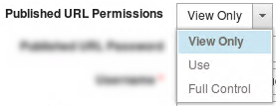

This dropdown list specifies the permissions associated with the Published URL that will be created.  Possible values are “View Only”, “Use”, and “Full Control”. The meaning of these permissions can be reviewed in the Skytap Help materials at this URL: [Skytap Published URL Help](https://cloud.skytap.com/docs/index.php/How_to_provide_access_to_a_VM_(or_a_group_of_VMs)_for_users_that_do_not_currently_have_a_Skytap_Cloud_user_account_(How_to_Provide_Published_URLs_for_your_users))

Published URL Password

If this property is specified, the value of this property will be assigned as a password that will be required before anyone using the created Published URL will be allowed to access the associated Skytap environment.

#### Username

Your Skytap User ID

The default value for this property is the “username” property from the Skytap action step titled “Skytap Authentication”.

#### Authentication Key

Your Skytap API Security Token

The default value for this property is the “password” property from the Skytap action step titled “Skytap Authentication”.

#### Proxy Host

The optional name of the proxy to use to connect to Skytap Cloud

#### Proxy Port

The optional proxy port on the above proxy host to use to connect to Skytap Cloud

### Output Properties

publishedURL

The text of the published URL is saved in the “publishedURL” output property.

This property can then be used as input to subsequent IBM UrbanCode Deploy workflow steps.

## Create Template from Environment

This Skytap Action allows you to create a Skytap Template from a specified Skytap Environment.

The ID of the created template is saved in the “templateID” output property.

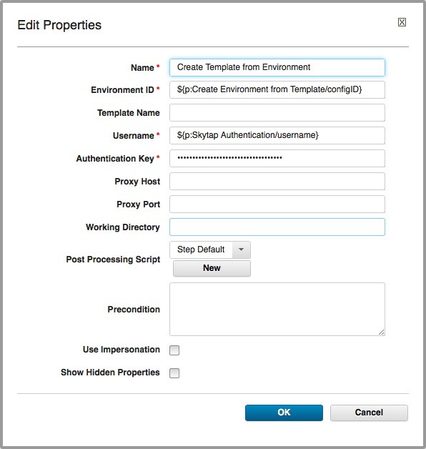

### Parameters

#### Environment ID

The Environment ID of the Skytap Environment from which a new Skytap Template is to be created.

You can specify a specific Skytap Environment ID (an integer), if one is known.  If the environment was created using a “Create Environment from Template” Skytap step action, you can specify the Skytap environment by specifying the “configID” output property from the appropriate “Create Environment from Template” Skytap action step.

The default value for this property is the “configID” output property from the Skytap action step titled “Create Environment from Template”

#### Template Name

This parameter allows you to specify a name for the created template.

#### Username

Your Skytap User ID

The default value for this property is the “username” property from the Skytap action step titled “Skytap Authentication”.

#### Authentication Key

Your Skytap API Security Token

The default value for this property is the “password” property from the Skytap action step titled “Skytap Authentication”.

#### Proxy Host

The optional name of the proxy to use to connect to Skytap Cloud

#### Proxy Port

The optional proxy port on the above proxy host to use to connect to Skytap Cloud

### Output Properties

templateID

The template ID of the created Skytap Template is saved in the “templateID” output property.

This property can then be used as input to subsequent IBM UrbanCode Deploy workflow steps.

## Delete Environment

This Skytap Action allows a user to delete the specified Skytap Environment.

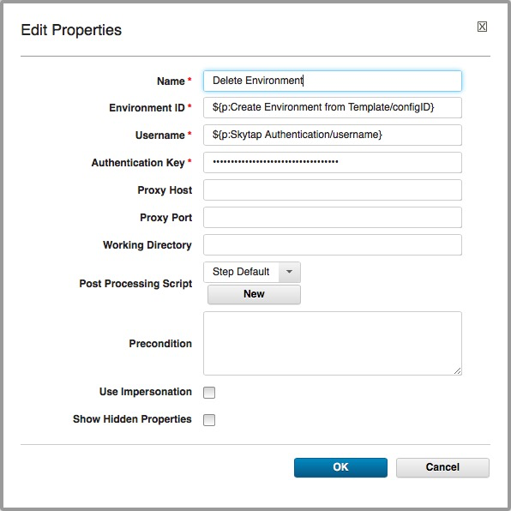

### Parameters

#### Environment ID

The ID of the Skytap Environment to delete.

You can specify a specific Skytap Environment ID (an integer), if one is known.  If the environment was created using a “Create Environment from Template” Skytap step action, you can specify the Skytap environment by specifying the “configID” output property from the appropriate “Create Environment from Template” Skytap action step.

The default value for this property is the “configID” output property from the Skytap action step titled “Create Environment from Template”

#### Username

Your Skytap User ID

The default value for this property is the “username” property from the Skytap action step titled “Skytap Authentication”.

#### Authentication Key

Your Skytap API Security Token

The default value for this property is the “password” property from the Skytap action step titled “Skytap Authentication”.

#### Proxy Host

The optional name of the proxy to use to connect to Skytap Cloud

#### Proxy Port

The optional proxy port on the above proxy host to use to connect to Skytap Cloud

### Output Properties

none

## Delete VM from Environment

This Skytap Action allows a user to delete the specified Skytap virtual machine from the specified Skytap Environment.

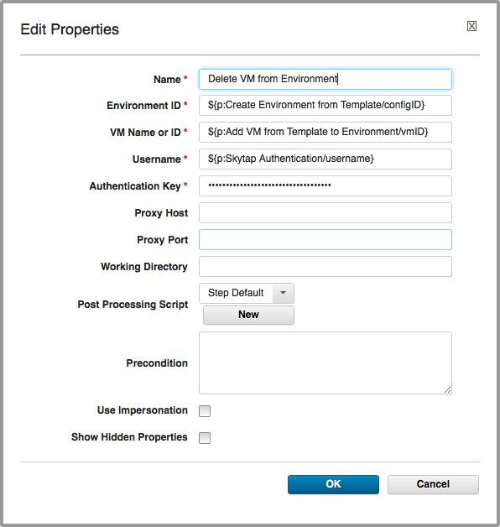

### Parameters

#### Environment ID

The ID of the Skytap Environment to delete.

You can specify a specific Skytap Environment ID (an integer), if one is known.  If the environment was created using a “Create Environment from Template” Skytap step action, you can specify the Skytap environment by specifying the “configID” output property from the appropriate “Create Environment from Template” Skytap action step.

The default value for this property is the “configID” output property from the Skytap action step titled “Create Environment from Template”

#### VM Name or ID

The name or numerical ID (an integer) of the virtual machine contained in the specified Skytap template

#### Username

Your Skytap User ID

The default value for this property is the “username” property from the Skytap action step titled “Skytap Authentication”.

#### Authentication Key

Your Skytap API Security Token

The default value for this property is the “password” property from the Skytap action step titled “Skytap Authentication”.

#### Proxy Host

The optional name of the proxy to use to connect to Skytap Cloud

#### Proxy Port

The optional proxy port on the above proxy host to use to connect to Skytap Cloud

### Output Properties

none

## Get VM ID

This Skytap Action allows a user to get the ID of a VM within a Skytap Environment.

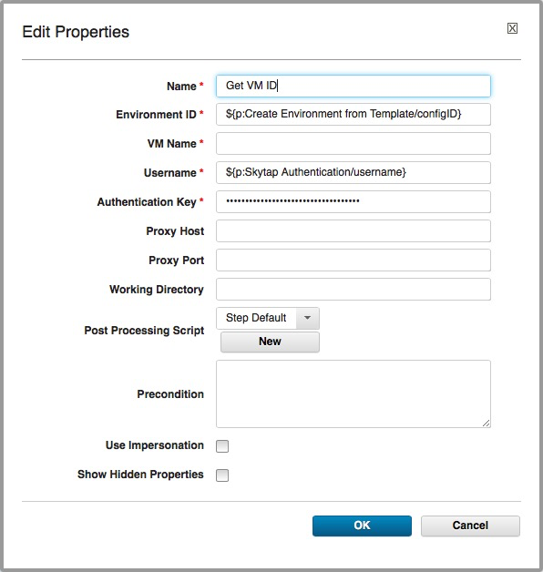

### Parameters

#### Environment ID

The ID of the Skytap Environment that contains the desired VM.

You can specify a specific Skytap Environment ID (an integer), if one is known.  If the environment was created using a “Create Environment from Template” Skytap step action, you can specify the Skytap environment by specifying the “configID” output property from the appropriate “Create Environment from Template” Skytap action step.

The default value for this property is the “configID” output property from the Skytap action step titled “Create Environment from Template”

#### VM Name

This parameter specifies the name of the Virtual Machine for which the ID is to be retreived.  Note that if the specified environment has more than one VM with the same name, the last VM with that name that is encountered in the Skytap Environment metadata definition will be selected.

#### Username

Your Skytap User ID

The default value for this property is the “username” property from the Skytap action step titled “Skytap Authentication”.

#### Authentication Key

Your Skytap API Security Token

The default value for this property is the “password” property from the Skytap action step titled “Skytap Authentication”.

#### Proxy Host

The optional name of the proxy to use to connect to Skytap Cloud

#### Proxy Port

The optional proxy port on the above proxy host to use to connect to Skytap Cloud

### Output Properties

vmID

The ID of the specified VM is saved in the “vmID” output property.

This property can then be used as input to subsequent IBM UrbanCode Deploy workflow steps.

## List Published Service for VM

The [Skytap Published Service](https://cloud.skytap.com/docs/index.php/Exposing_a_Configuration_to_the_Public_Internet#Setting_Up_a_Published_Service) for the port specified in the “Port Number” parameter in the network with the name specified by the “Network Name” parameter in the virtual machine specified by the “VM Name” parameter in the environment specified by the “Environment ID” parameter is saved to the “serviceAddress” output property.

If the specified environment has more than one Virtual Machine with the name specified by the “Virtual Machine Name” parameter, the last Virtual Machine with the specified name that is listed in the environment metadata will be used.

If the specified environment has more than one network with the name specified by the “Network Name” parameter, the last network with the specified name that is listed in the environment metadata will be used.

The text of the public URL and port in the form “public-URL:port-number” is saved in the “serviceAddress” output property.

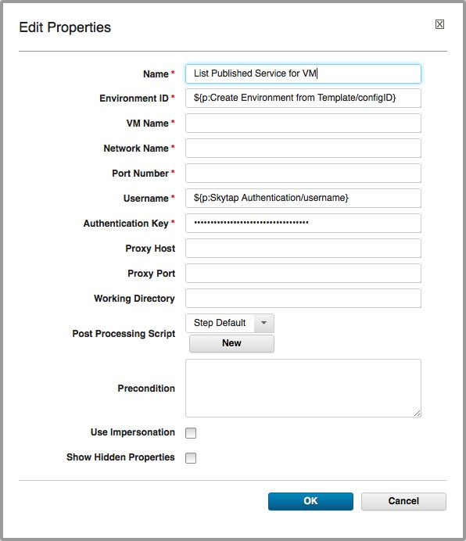

### Parameters

#### Environment ID

The ID of the Skytap Environment that contains the VM with the desired published service.

You can specify a specific Skytap Environment ID (an integer), if one is known.  If the environment was created using a “Create Environment from Template” Skytap step action, you can specify the Skytap environment by specifying the “configID” output property from the appropriate “Create Environment from Template” Skytap action step.

The default value for this property is the “configID” output property from the Skytap action step titled “Create Environment from Template”

#### VM Name

This property specifies the Virtual Machine to which the Published Service is to be attached.

Note that if the specified environment has more than one VM with the same name, the last VM with that name that is encountered in the Skytap Environment metadata definition will be selected.

#### Network Name

This parameter specifies the Network to which the Published Service is to be attached.

Note that if the specified VM has more than one network with the same name, the last network with that name that is encountered in the Skytap Environment metadata definition will be selected.

#### Port Number

This parameter specifies the Port to which the Published Service will be connected.

#### Username

Your Skytap User ID

The default value for this property is the “username” property from the Skytap action step titled “Skytap Authentication”.

#### Authentication Key

Your Skytap API Security Token

The default value for this property is the “password” property from the Skytap action step titled “Skytap Authentication”.

#### Proxy Host

The optional name of the proxy to use to connect to Skytap Cloud

#### Proxy Port

The optional proxy port on the above proxy host to use to connect to Skytap Cloud

### Output Properties

serviceAddress

The text of the public URL and port in the form “public-URL:port-number” is saved in the “serviceAddress” output property.

This property can then be used as input to subsequent IBM UrbanCode Deploy workflow steps.

## List Published URL for Environment

The environment desktops URL with the specified Published URL Name for the specified environment is saved in the “publishedURL” output property.  Listing of published URLs for individual VMs in a environment are not supported.

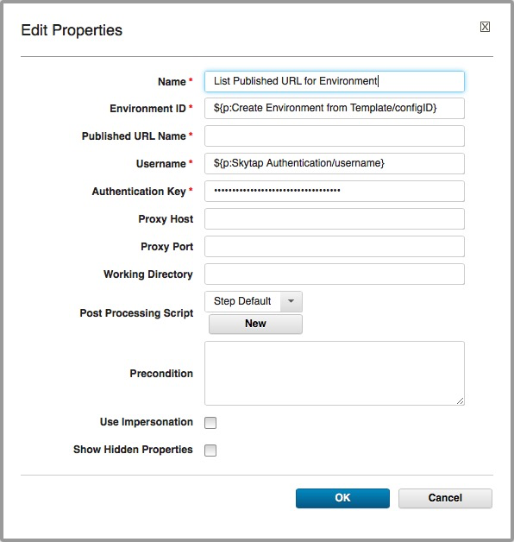

### Parameters

#### Environment ID

The ID of the Skytap Environment that contains the desired published URL.

You can specify a specific Skytap Environment ID (an integer), if one is known.  If the environment was created using a “Create Environment from Template” Skytap step action, you can specify the Skytap environment by specifying the “configID” output property from the appropriate “Create Environment from Template” Skytap action step.

The default value for this property is the “configID” output property from the Skytap action step titled “Create Environment from Template”

#### Published URL Name

This parameter specifies the name of the desired published URL.

If more than one published URL in the specified environment has the same name, the last URL encountered in the environment metadata will be selected.

#### Username

Your Skytap User ID

The default value for this property is the “username” property from the Skytap action step titled “Skytap Authentication”.

#### Authentication Key

Your Skytap API Security Token

The default value for this property is the “password” property from the Skytap action step titled “Skytap Authentication”.

#### Proxy Host

The optional name of the proxy to use to connect to Skytap Cloud

#### Proxy Port

The optional proxy port on the above proxy host to use to connect to Skytap Cloud

### Output Properties

publishedURL

The text of the public URL is saved in the “publishedURL” output property.

This property can then be used as input to subsequent IBM UrbanCode Deploy workflow steps.

## Set VM User Data

The VM User Data for the specified VM in the specified Skytap Environment is set to a new value. VM User Data is available via within a running VM by using a REST call to the Skytap Metadata Service. You can find out more about the Skytap Metadata Service in the [Skytap Help Pages](https://cloud.skytap.com/docs/index.php/VM_and_Configuration_Metadata).

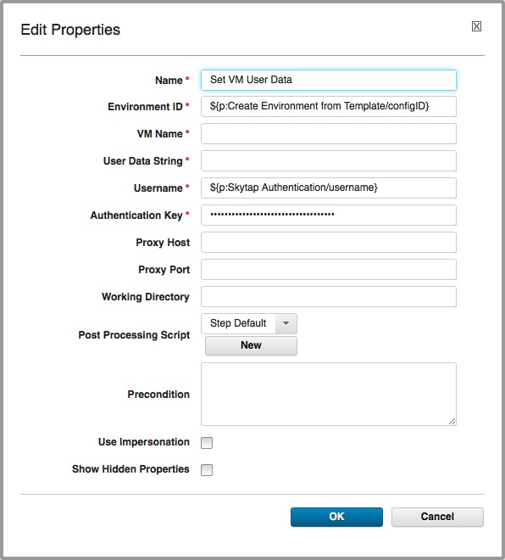

### Parameters

#### Environment ID

The ID of the Skytap Environment that contains the VM for which the User Data is to be set.

You can specify a specific Skytap Environment ID (an integer), if one is known.  If the environment was created using a “Create Environment from Template” Skytap step action, you can specify the Skytap environment by specifying the “configID” output property from the appropriate “Create Environment from Template” Skytap action step.

The default value for this property is the “configID” output property from the Skytap action step titled “Create Environment from Template”

#### VM Name

This property specifies the Virtual Machine for which the User Data is to be set.

Note that if the specified environment has more than one VM with the same name, the last VM with that name that is encountered in the Skytap Environment metadata definition will be selected.

#### User Data String

The string value to which the VM user data is to be set. Note that any data previously in the VM user data will be overwritten.

#### Username

Your Skytap User ID

The default value for this property is the “username” property from the Skytap action step titled “Skytap Authentication”.

#### Authentication Key

Your Skytap API Security Token

The default value for this property is the “password” property from the Skytap action step titled “Skytap Authentication”.

#### Proxy Host

The optional name of the proxy to use to connect to Skytap Cloud

#### Proxy Port

The optional proxy port on the above proxy host to use to connect to Skytap Cloud

### Output Properties

None